Ola Hallengren Maintenance Jobs - SQL Server
Supported versions:
SQL Server 2008, SQL Server 2008 R2, SQL Server 2012, SQL Server 2014, SQL Server 2016, SQL Server 2017, SQL Server 2019, Azure SQL Database, and Azure SQL Database Managed Instance.
https://ola.hallengren.com/downloads.html
The SQL Server Maintenance Solution is available on GitHub. (Below Link)
https://github.com/olahallengren/sql-server-maintenance-solution
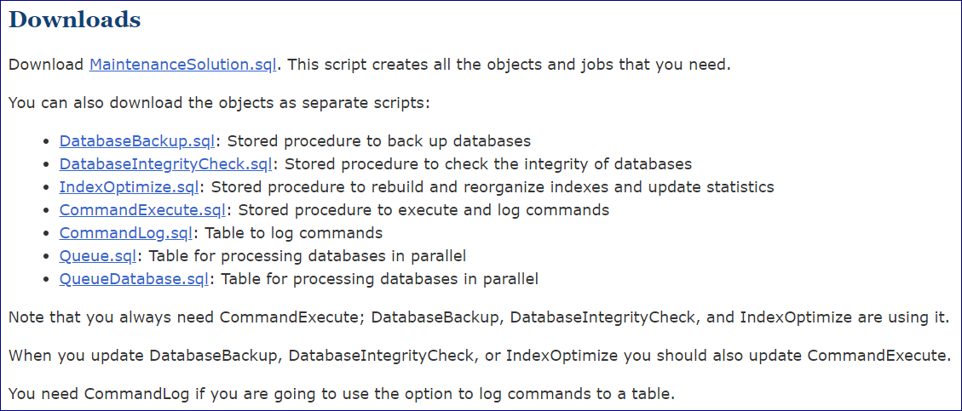
Supported Versions:
SQL Server 2005
https://ola.hallengren.com/downloads-sql-server-2005.html
The SQL Server Maintenance Solution is available on GitHub. (Below Link)
https://github.com/olahallengren/sql-server-maintenance-solution
